- \Operation\Tube filling\Dosing\Tube filling – dosing component A - timing
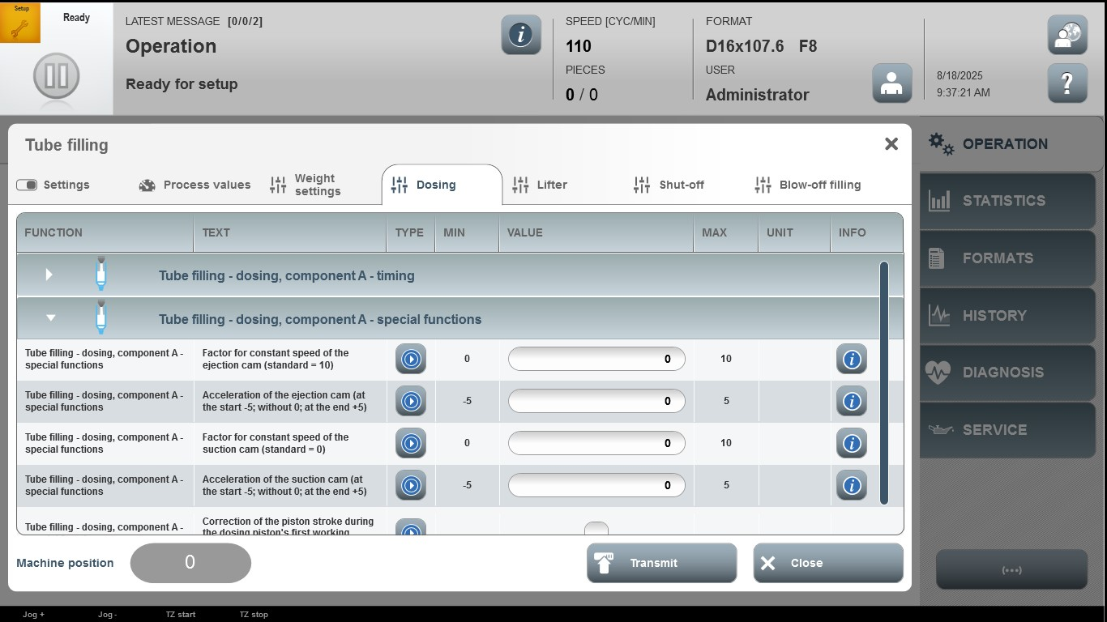

Acceptance criterion | Limits | Pass / Fail: Dev-No. | Date | Initials
Screen matches screenshot | N / A
Factor for constant speed of the ejection cam (standard=10) | 0…10
Acceleration of the ejection cam (at the start -5; without0; at the end +5) | -5…5
Factor for constant speed of the suction cam (standard=0) | 0…10
Acceleration of the suction cam (at the start -5; without 0; at the end+5) | -5…5

